Testing report of Salharo

* User is able to click in following blank space to move on Home Page.



* When we search something, page heading is also change.

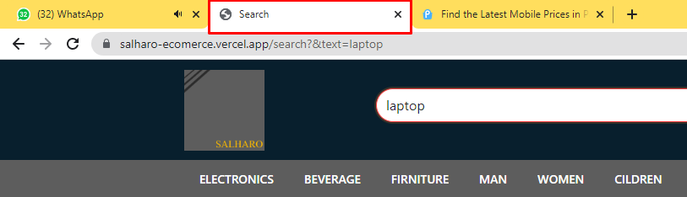

* Slider image is not in correct size.



* Arrows should middle of the image.



* Category slider arrow should in proper formate.

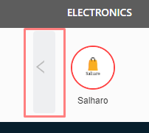

* Div should in same highlighted color.



* We are not able to to select parent category.

